Bahria University,

Karachi Campus



LAB EXPERIMENT NO.

03

LIST OF TASKS

|  |  |
| --- | --- |
| TASK NO | OBJECTIVE |
| 1 | **Create basic calculator application on Console Application that performs basic arithmetic operations like (add, subtract, multiply, divide ….)** |
| 2 | **Create Winform application that authenticate user with hardcoded username and password if user authenticated new form will be open that takes user information as an input and on button click all information will be displayed in dialog box.** |
|  |  |
|  |  |
|  |  |
|  |  |

Submitted On:

**06-04-2022**

**Task 1: Create basic calculator application on Console Application that performs basic arithmetic operations like (add, subtract, multiply, divide ….)**

**Solution:**

class Program {

static bool Menu() {

Console.Clear();

Console.WriteLine("Enter First Number");

double a = double.Parse(Console.ReadLine());

Console.WriteLine("Enter Second Number");

double b = double.Parse(Console.ReadLine());

Console.Clear();

Console.WriteLine("1)Addition\n2)Subtraction\n3)Multiplication\n4)Division\n5)Exit");

Console.Write("Choose:");

int c = int.Parse(Console.ReadLine());

switch (c) {

case 1:

Console.WriteLine("Result :" + (a + b));

Console.ReadLine();

return true;

case 2:

Console.WriteLine("Result :" + (a - b));

Console.ReadLine();

return true;

case 3:

Console.WriteLine("Result :" + (a * b));

Console.ReadLine();

return true;

case 4:

Console.WriteLine("Result :" + (a / b));

Console.ReadLine();

return true;

case 5:

return false;

default:

return true; }}

static void Main(string[] args)

{

bool x = true;

while (x)

{

x = Menu(); } }}

**Output:**

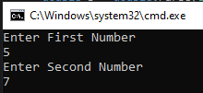

**Task 2: Create Winform application that authenticate user with hardcoded username and password if user authenticated new form will be open that takes user information as an input and on button click all information will be displayed in dialog box.**

**Solution:**

**Form 1:**

public partial class Form1 : Form {

public static string name;

public Form1() {

InitializeComponent(); }

private void textBox1_TextChanged(object sender, EventArgs e){}

private void label1_Click(object sender, EventArgs e){}

private void label3_Click(object sender, EventArgs e){}

private void textBox2_TextChanged(object sender, EventArgs e){}

private void label2_Click(object sender, EventArgs e){}

private void button1_Click(object sender, EventArgs e)

{if (textBox1.Text != "" && textBox2.Text != "")

{

this.Hide();

name = textBox1.Text;

Form2 f2 = new Form2();

f2.Show();}}

private void Form1_Load(object sender, EventArgs e){}}}

**Form 2:**

{

public partial class Form2 : Form {

public static string name;

public static string reg;

public static string dep;

public Form2(){

InitializeComponent();}

private void label2_Click(object sender, EventArgs e){}

private void labelb_Click(object sender, EventArgs e){}

private void label5_Click(object sender, EventArgs e){}

private void labela_Click(object sender, EventArgs e){}

private void button1_Click(object sender, EventArgs e){

name = textBox1.Text;

reg = textBox2.Text;

dep = textBox3.Text;

this.Hide();

Form3 f3 = new Form3();

f3.Show();}

private void textBox1_TextChanged(object sender, EventArgs e){}

private void textBox2_TextChanged(object sender, EventArgs e){}

private void textBox3_TextChanged(object sender, EventArgs e){}

private void Form2_Load(object sender, EventArgs e){}}}

**Form 3:**

public partial class Form3 : Form{

public Form3(){

InitializeComponent();}

private void label1c_Click(object sender, EventArgs e){}

private void label1_Click(object sender, EventArgs e){}

private void label3_Click(object sender, EventArgs e){}

private void label1a_Click(object sender, EventArgs e){}

private void label4_Click(object sender, EventArgs e){}

private void label1b_Click(object sender, EventArgs e){}

private void label5_Click(object sender, EventArgs e){}

private void Form3_Load(object sender, EventArgs e){}

label1a.Text = Form2.name;

label1b.Text = Form2.reg;

label1c.Text = Form2.dep;{}

**Output:**

081

Muaaz

081

Muaaz

Bahria University,

Karachi Campus

LAB EXPERIMENT NO.

**04**

LIST OF TASKS

|  |  |
| --- | --- |
| TASK NO | OBJECTIVE |
| 1 | **Design Facebook login page using html, css and javascript -> the page takes username and password and with javascript alert message will be displayed.** |

Submitted On:

**06-04-2022**

**Task 1: Design Facebook login page using html, css and javascript -> the page takes username and password and with javascript alert message will be displayed.**

**Solution:**

<!DOCTYPE html>

<html lang="en">

<head>

<meta charset="UTF-8">

<meta http-equiv="X-UA-Compatible" content="IE=edge">

<meta name="viewport" content="width=device-width, initial-scale=1.0">

<link rel="stylesheet" href="Facebook.css">

<title>Facebook</title>

<style type="text/css">body{

background-color: #f0f2f5;

font-family: Arial, Helvetica, sans-serif;}

.form{

width: 400px;

height: 350px;

margin: 0 auto;

margin-top:150px ;

margin-left: 900px;

background-color: white;

padding: 15px;

border-radius: 6px;

box-shadow: 5px 5px 5px gainsboro;}

input{

width: 375px;

height:30px;

margin-top: 15px;

border-radius: 7.5px;

border: 1px solid gainsboro;

padding: 10px;

font-size: 15.5px;

float: right;

display: inline-block; }

input:hover{

border: 1px solid #1877f2;}

button{

width: 400px;

height:50px;

margin-top: 15px;

border-radius: 7.5px;

color: white;

font-size: large;

font-weight: bold;

background-color: #1877f2;

border: none;}

a{

text-decoration: none;

color:#18a4f7;

margin-left: 125px;}

input::placeholder{

color:#9094a9;}

hr{

border: 1px solid gainsboro;}

.btn{

width: 200px;

height:50px;

/* margin-top: 15px; */

border-radius: 7.5px;

color: white;

font-size: large;

font-weight: bold;

background-color: #42b72a;

border: none;

margin-left: 100px;}

#fbimg{

width: 500px;

height: 300px;

margin-top:75px ;

margin-left:200px ;

float: left;

display: inline-block;

}

#fbtext{

font-size: 27.5px;

margin-top:-7.5px ;}

img{

margin-left:-35px;

width: 350px;

}</style>

</head>

<script type="text/javascript">

function btnclick() {

var username=document.getElementById("Txtuser").value;

alert("Welcome "+ username)}

</script>

<body>

<div id="fbimg">

<div class="img"><img src="images/fb.svg" alt="" id="fb"></div>

<p id="fbtext">Facebook helps you connect and share

with the people in your life. </p>

</div>

<div class="form">

<form>

<label><input type="text" id="Txtuser" placeholder="UserName"><br></label>

<label><input type="password" placeholder="Password"><br></label>

<button onclick="btnclick()" >Log In</button><br><br>

<a href="">Forgotten password?</a><br><hr><br>

<button class="btn" >Create New Account</button><br>

</form>

</div>

</body>

</html>

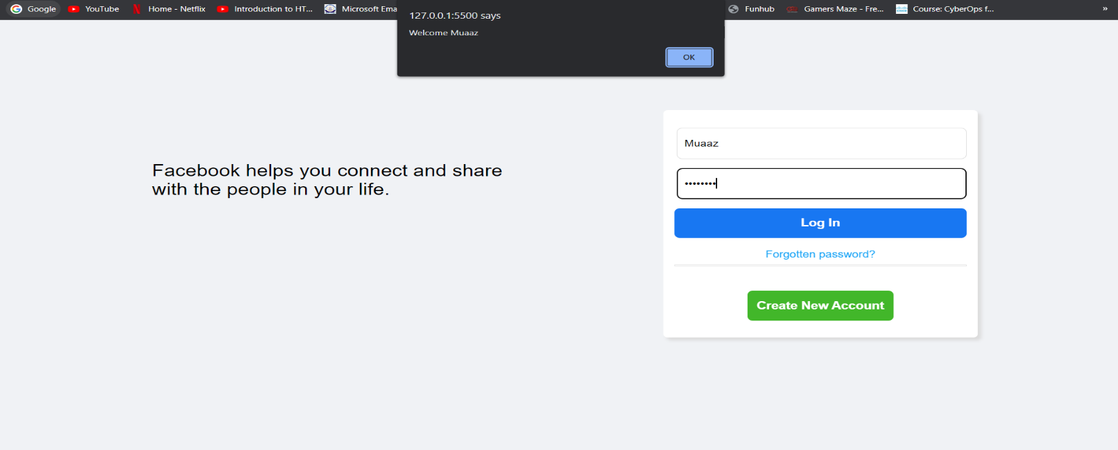**Output:**